STANDARD OPERATING PROCEDURE
Light Motor Vehicle Operation



ODISHA MINING CORPORATION LTD.
KODINGAMALI BAUXITE MINE

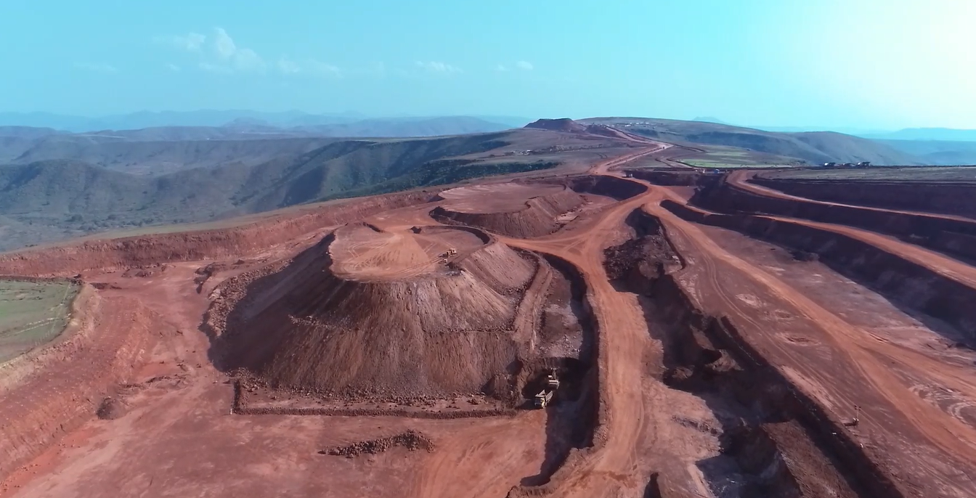

Authorized By:

- PURPOSE:

To provide the standard operating procedure for Light Motor Vehicle operation in Kodingamali Bauxite Mine.

- SCOPE:

This procedure is applicable for safe Operation of Light Motor Vehicle in Kodingamali Bauxite Mine.

- RESPONSIBILITY:

 | L.M.V Operation | L.M.V Operator
 | L.M.V Maintenance | Maintenance vehicle In-charge
 | Field Operation | Supervisor/Shift In-charge
 | Operational Control | Area in-charge

- SAFETY AND HEALTH HAZARDS:

- Slip/trip/fall.
- Head on Collision.
- Roll Over/Toppling of L.M.V.
- Hitting to other Truck/Structure/Persons.
- Dust generation during Operation.
- Noise during Operation.
- Vibration during Operation.
- Diesel/ Engine oil, gear Oil - Inflammable, Fire hazards.
- Acid Batteries- Skin contact can lead to extensive and severe burns and highly toxic.

In order to avoid injuries to personal and damage to machinery, the following precautions are very important.
- Work required PPE i.e. with safety shoes, helmet, dust musk, fluorescent jacket suitable for long distance visibility etc.
- Adherence to Traffic Rules guidelines framed by Mines Manager.
- Pre Operation Safety features checklist.
- Regular Checks & Maintenance.
- Use seat belt while driving.

Note: Report immediately to Supervisor, Shift Incharge and Safety officer for any incident/accident.

- ENVIRONMENT ASPECT:

- Dust generation
- Noise Pollution
- Vibration
- Oil Spillage

Preventive measures:

- Regular Water Sprinkling on Haul Roads for dust control.
- Use of Dust Mask/Earplug.
- Use seat belt while driving to avoid jerking.

- TOOLS:

All Work required PPEs like Safety Helmet, Safety shoes, Nose mask, Ear Plug & Jacket.

- PROCEDURE:

Experienced persons should be employed for the job. Ensure that persons having valid driving license and equipped with all required PPEs.

Duties of LM.V. Operator

Before Start Operator shall check the followings-
- Check the condition of horn, engine oil, water, air pressure before starting the machine and ensure that these are in good working condition.
- Check oil leakage in high pressure hose joints, engine and final drive case.
- Check water leakage in radiator and engine.
- Check wiring, circuits, electrical connections, battery condition, start of motor, alternator, terminals for any sign of damage or short circuiting
- Check for play and travel of each lever, turn the machine left and right at a safe place to check traveling and steering levers, and that machine is not giving any unusual noises.
- No fire element should be near while checking or replenishing oils, avoid overflow and ensure all body covers and caps are tightened.
- Check that no other parts are damaged or missing.

NORMAL OPERATION:

Pre-Start (Duties of Driver)

- Driver will ensure not to carry any combustible material in cabin.
- Check L.M.V. thoroughly for any leakage or damage.
- Check L.M.V. for its all safety features and specially fire extinguisher.
- Check all tyre condition.
- Check back & front horn.
- Check all seat belts.
- Check all tyre pressure.
- Check engine oil & fuel level.
- Check all nut & bolts tightness.

While driving of L.M.V. (Duties of Driver)

- Not use mobile phones while L.M.V drive.
- Shut-off engine running of vehicle while parking.
- Use wheel stopper while parking.
- Do not light up fire or allow anybody else to do so.
- Wearing seat belt while driving.
- Any leakage or any damage which may cause leakage should be reported to shift supervisor/ shift in charge.
- Smoking is prohibited inside the vehicle during vehicle drive.
- Blow horn to get the attention of L.M.V. driver from at least 30m distance.
- As per seating capacity person should be seat and use seat belt while driving.
- Speed should be not more then 20 Km / Hr inside the mines.
- Ensure over load while material transfer, Always maintain safe load.
- Ensure no over taking inside mines.
- Always give preference to heavy vehicle.

During L.M.V Driving SHUT DOWN:

- Strictly follow the speed limit.
- Do not park the vehicle in crowded area.
- Follow all the traffic rules.
- Park at designated area.
- Check for any leakage and report immediately for any defect.
- Close the all side and back door & provide wheel stopper.
- Park the vehicle in safe place.
- Switch off all apparatus which work on electricity or engine.
- Remove ignition key.

